Route and Item Tracking

Route and Item Tracking (RIT) is a CRM (Customer Relationship Management) software built for transportation industry. RIT runs on Microsoft CE or Palm OS based Smart Devices like iPAQ, Garin, Palm. Following are the key features of application:

- Wireless ready application
- Uses Webservice technology to communicate with server
- Authenticate users using the Cryptographic secure logic
- Downloads route information for daily deliveries
- Guides user to follow a pre defined route
- Records arrival and departure time at each retail store location
- Barcode scanning to track products being delivered at every retail store
- Record exception codes for damaged packages
- Record reasons for undelivered items
- Collects payment information for every Stop
- Supports three modes of payment collection Cash / Check / Credit Card
- Collect the electronic signature of the receiver at every store location
- Print a summary of delivery receipt for the receiver
- Provides option to email / fax the delivery information
- On the fly version control
- On the fly database schema changes
- Uploads all the data from PDA to server when the stops for the day are finished
- Stable client – server handshake mechanism
- Ability to store uploaded data from server to Oracle / SQL Server / AS400.

Brief work flow of the RIT software follows:

Logging In

User will be authenticated only when he/she wants to get data from server for a particular manifest with details of all the routes and items to be delivered. The client-server communication passes through cryptographic algorithm layer for secure transmission of data.

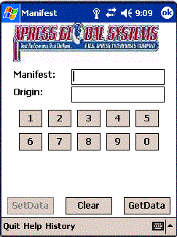
Web service call to get data from server
Web service call to send data to server

Tap getData button, it will authenticate user using Cryptographic secure logic. It will also get data for that particular manifest from the server, populate it in your PDA database and takes you to next screen.

Scan items:

User will select the stop that he/she has reached and will work on detailed view screen for that particular stop. It will contain information about all the items that need to be delivered in that stop.

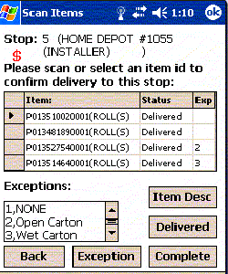
Substitute for scanner or bad barcode
Indicates that user needs to collect money for this stop

To track exceptional (damaged) deliveries

Built in scanning utility will help user to scan items and update the status for them as Delivered. If for some reason the scanner is mal functioning or the barcode from some box can not be scanned; user can match the barcode and manually tap the Delivered button and it will be as good as the item has been scanned.

Once all the Items for the stop have been scanned, user will select complete button. If there was some items which were not found on truck, user will be taken to following Undelivered items screen.

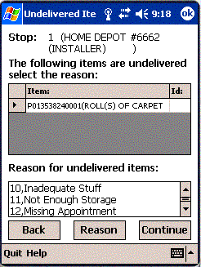
User will need to select the reason for undelivered item form drop down

User cannot proceed further to payment collection screen unless he/she selects the reason for undelivered items from the predefined reasons. Once the reason has been registered user selects continue and move to payment information screen.

Payment Information screens:

Here freight Charges will be populated along with the expected mode of payment. User can expect the payment in Cash / Check or Credit Card.

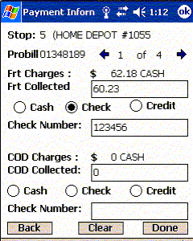
Two images which work as next and back to traverse through all probills for a stop

Once all the payment for different groups and items has been collected user will proceed by pressing done button. Summary of all the payment with total of cash amount and different check numbers will be shown.

Electronic Signature and summary for customer:

Once user confirms all the different payment amounts in summary screen, the application will proceed to collect electronic signature from the customer who has collected the Freight.

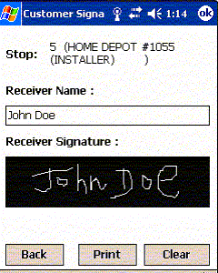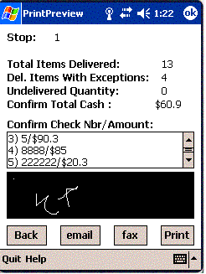

Once user selects the print option the Summary of Print receipt will be shown. Here customer will also have a choice of getting Email / Fax / Print of the summary. Once the confirmation message has been printed or electronically sent to customer, user is ready to depart from the stop and the Depart screen will appear to capture the depart timings.

Application does keep history data of last 10 transferred manifests information. Application also has an ability to send any historical data back to server if needed. Moreover, application is highly scalable and easy to maintain. Any changes in database schema or code changes that lead to new versions of the code will be handled on the fly at each client (PDA) level.

Please feel free to email at info@balajitechies.com for any further details or user reference guide for the application.

